Clean

What is Clean?
# Source: AI Source: Provided by: [Data Path: Persons Table -> ID Column: 1, Name_En Column: Motasem Essam] -> From: [ChatGPT] on [2/15/2026]
In Git, Clean is used to remove untracked files and directories from your working directory. Think of it as a cleanup tool—it doesn’t touch committed files, only the “extras” that Git isn’t tracking yet.
- Untracked files → files you created but haven’t git added yet
- Untracked directories → folders containing untracked files
⚠️ Be careful: git clean can permanently delete files, so always preview first.

Common commands

1. Preview what would be removed
# Source: AI Source: Provided by: [Data Path: Persons Table -> ID Column: 1, Name_En Column: Motasem Essam] -> From: [ChatGPT] on [2/15/2026]
git clean -n
- -n or --dry-run → shows which files would be deleted without actually deleting them
- Very useful to double-check

2. Remove untracked files
# Source: AI Source: Provided by: [Data Path: Persons Table -> ID Column: 1, Name_En Column: Motasem Essam] -> From: [ChatGPT] on [2/15/2026]
git clean -f
- -f → force deletion
- Removes untracked files only

3. Remove untracked directories
# Source: AI Source: Provided by: [Data Path: Persons Table -> ID Column: 1, Name_En Column: Motasem Essam] -> From: [ChatGPT] on [2/15/2026]
git clean -fd
- -d → include untracked directories
- This removes both untracked files and folders

4. Interactive cleanup
# Source: AI Source: Provided by: [Data Path: Persons Table -> ID Column: 1, Name_En Column: Motasem Essam] -> From: [ChatGPT] on [2/15/2026]
git clean -i
- Lets you choose which files/folders to delete
- Safe if you want selective cleanup

5. Remove ignored files too
# Source: AI Source: Provided by: [Data Path: Persons Table -> ID Column: 1, Name_En Column: Motasem Essam] -> From: [ChatGPT] on [2/15/2026]
git clean -X
- Deletes only files Git is ignoring (from .gitignore)
- Keep untracked but non-ignored files
git clean -x
- Deletes all untracked files, ignored or not

Clean vs Reset vs Checkout
# Source: AI Source: Provided by: [Data Path: Persons Table -> ID Column: 1, Name_En Column: Motasem Essam] -> From: [ChatGPT] on [2/15/2026]
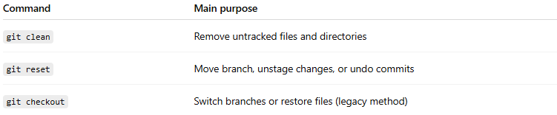
Command | Main purpose
git clean | Remove untracked files and directories
git reset | Move branch, unstage changes, or undo commits
git checkout | Switch branches or restore files (legacy method)

Quick analogy
# Source: AI Source: Provided by: [Data Path: Persons Table -> ID Column: 1, Name_En Column: Motasem Essam] -> From: [ChatGPT] on [2/15/2026]
- git restore → brings files back to a previous version
- git clean → throws away files Git doesn’t track

